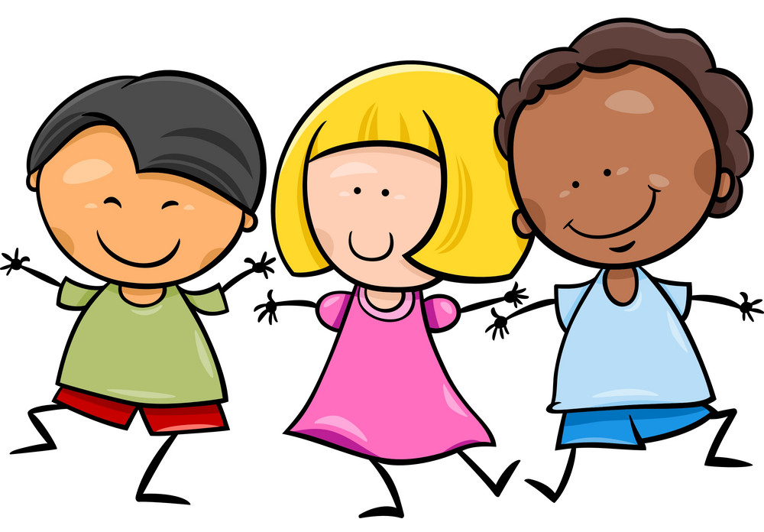
Key:
Blue 2YO – 3YO
Purple 3YO - 4YO
Key Texts
Only One You by Linda Kranz
What I like About Me! By Allia Zobel
Head, Shoulders, Knees and Toes
If You’re Happy and You Know It

Literacy
I enjoy sharing a book with an adult .
I have a favourite book.
I can repeat words and phrases from familiar stories.
I can develop play around my favourite stories.
I enjoy drawing freely
I can sometimes give meaning to the marks I make – “That is mummy.”
I am starting to understand that print has meaning.
I can recognise different sounds such as car, cow, dog, bell.

Communication and Language
I know and respond to my name.
I can focus on an activity I choose.
I can say some words about what I like.
I like to play ‘home’ in the roleplay corner by acting out familiar scenarios.
I know and recognise who is in my family.
I like to listen to stories.
I can sing along to songs.
I can start a conversation with an adult or a friend.

Spirituality
Connect by making new friendships
Respect our class community
Reflect on my achievements over the term.

R.E
I will begin to learn some of the day routines and rules of the nursery.
I will partake in the lunchtime ‘thank you’ prayer.
I will be learning about the school value thankfulness.

Expressive Arts and Design
I can join in with songs and rhymes, making some sounds. I am starting to join in with actions.
I like to explore different instruments and play them in different ways.
I can recognise key features of a face.
I can make marks and sometimes give meaning to the marks made.
I am developing pretend play – pretending one object represents another such as holding a wooden block to my ear and pretending it’s a phone.
Explore using different materials in my artwork such as paint, chalk, glue or pencils.
I am beginning to make simple models and talk about my ideas.
I enjoy pretend play.
Mathematics
I take part in finger rhymes with numbers.
I can compare amounts ‘lots’, ‘more’ or ‘same’.
I can count in everyday contexts, sometimes skipping numbers ‘1-2-3-5’
I can complete an inset puzzle.
I can compare weights and size using gesture and language ‘bigger/little/smaller’, ‘high/low’, ‘tall’
Notice a pattern and arrange a pattern.

Understanding the World
I make connections between the features of my family and other families.
I can notice differences between people.
I can use my senses in hands-on exploration of natural materials.
I can talk about what I see around me.
I like to explore how things work.
All About Me!
Nursery Autumn 1
Week 1 - 4
Personal, Social and Emotional Development
I am developing friendships with other children.
I am becoming independent (“me do it!”)
I am beginning to talk about my feelings and understand my emotions.
I am learning to use the toilet by myself.
I can select resources that I need (spade to dig a hole in the sand)
I am beginning to show more confidence in social situations.
I am learning to play with other children.
I can follow some simple rules and routines.

Physical Development
I can clap and stamp to music.
I can fit myself into spaces such as tunnels and dens.
I can walk, run, jump and climb – starting to use the stairs independently.
I am beginning to show a desire to be independent such as dressing and undressing myself.
I am starting to use cutlery.
I am developing my movement, balance and riding and balls skills.
I can use alternative feet when climbing up and down.
I am practicing to skip, hop, stand on one leg and hold a pose like for musical statues.

