Starting Reception 2025-2026
All about me
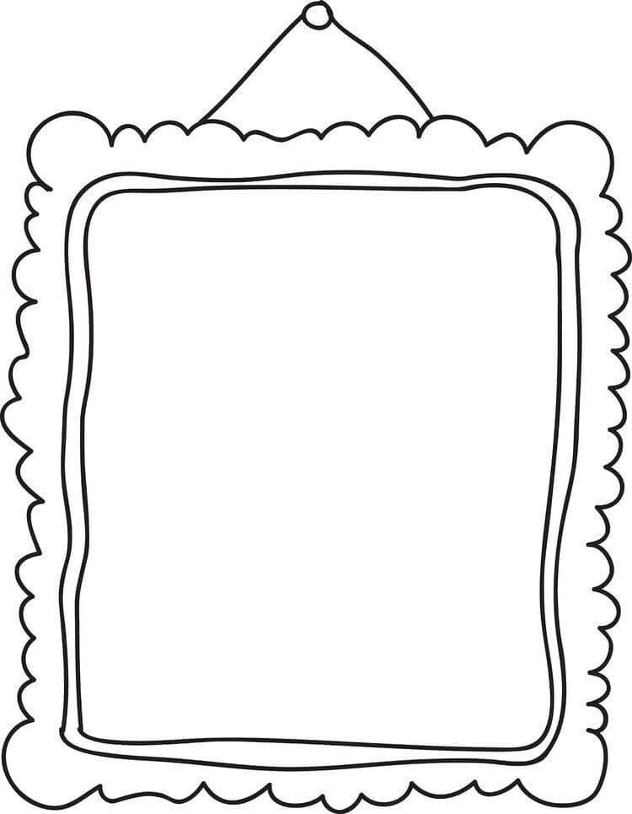
This is me…

My name is:

__________________________________________________________
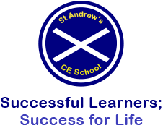

All about me
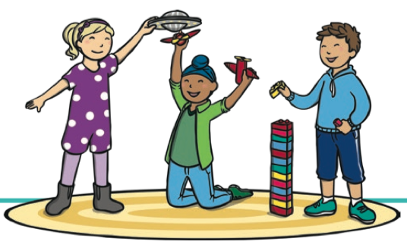
Please draw or write in the boxes below.
I like playing with… (sand, water tray, small world toys, lego, dressing up)
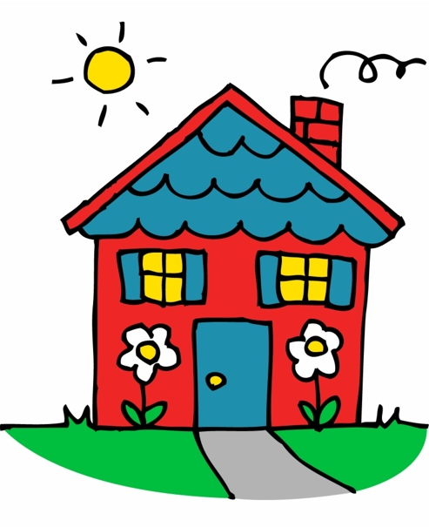
I live with…

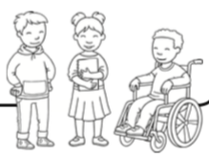
Things that I do not like…
My friends are called…

My new school

How do you feel about starting school?
Please colour the face that shows how you feel.
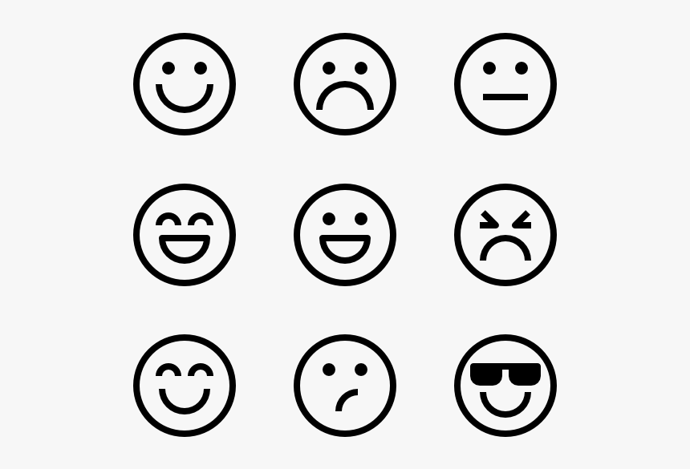

How are you going to come to school?
Please colour how you will be coming to school each day.
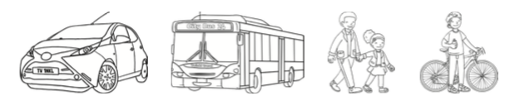

Questions I have for my new teacher…

________________________________________________________________________________________________________________________________________________________________________________________

